AxiumValuation
OFFICIAL VALUATION REPORT
J & K Bank
Date Generated: 3/4/2026

TEMPLATE VARIABLES
Property Detail | Assessed Value / Information
Name of the party/owner | Prasanth
Name of the panel valuer | hari
Address of the property | Axium Health Solution Private Limited, C/o, Mount Poonamallee Rd, Gandhi Nagar, Porur, Chennai, Tamil Nadu 600116
Name/s of the Reported owner/ name/s of persons in whose names/s the property registered and address | Axium Health Solution Private Limited, C/o, Mount Poonamallee Rd, Gandhi Nagar, Porur, Chennai, Tamil Nadu 600116
Purpose of valuation | revaluation
Date of inspection | 04-03-2026
List of documents produced for perusal | Pancard, Adhar Card, Patta
Date of valuation | 04-03-2026
Approximate Distance from the branch to the property | 4.2km
Situation/location/brief description of the land / site | N/A
Lat & long | N/A
Google Map Link | N/A
Boundary Details of the Property as per Document | N/A
Boundary Details of the Property as per Site | N/A
Assuming the entire property is let out, the probable monthly rent and advance | N/A
Whether the building plan has been approved? | N/A
If yes, date of approval, approving authority, and whether the building has been constructed as per the approved plan at the time of inspection | N/A
If no, the reason for non-approval | N/A
General Remarks | N/A
The total area (Extent of the site/Land) | N/A
Description of the site/land | N/A
Character of locality | N/A
Class of locality | N/A
Classification | N/A
Development of surrounding areas | N/A
Is the locality subjected to frequent flooding | N/A
Feasibility to the civil amenities like schools, hospital, offices, market etc. | N/A
Shape of land | N/A
Type of use to which it can be put | N/A
Any other restriction of usage | N/A
Nature of right, whether lease hold | N/A
Road facility | N/A
Is it a corner plot | N/A
Lift | N/A
Carpark | N/A
Water supply/potentiality | N/A
Underground sewerage system | N/A
Any other sentimental social issue Which may affect the value. | N/A
Type of construction | N/A
Quality of construction | N/A
Appearance of the building | N/A
Number of floors | N/A
Maintenance of the building | N/A
Description of the building | N/A
Area Details | N/A
Foundation | N/A
Superstructure | N/A
Roof | N/A
Doors | N/A
Windows | N/A
Age of the building | N/A
Estimated further life of the building | N/A
Depreciation | N/A
Replacement Rate of Building | N/A
Extent of Land as per deed | N/A
Extent of Land as per Patta | N/A
Extent of Land for Valuation | N/A
Extent of Building for Valuation | N/A
Guideline Value of Property per Sq Ft | N/A
Prevailing unit market rate of land | N/A
Adopted rate of valuation | N/A
Building Valuation | N/A
Remarks about the property | N/A
VALUE OF BUILDING | N/A
Land Extent | N/A
Building Extent | N/A
Guide Line Value | N/A
Guide Line Value of Land | N/A
Guideline Value of Building | N/A
Guide Line Value of Property | N/A
Adopted Market Value of Land | N/A
Value of Land | N/A
Total Value of Property | N/A
Total Property | N/A
Fair Market Value of the above said property | N/A
Realizable Sale Value | N/A
Distress Sale Value | N/A
Total Guideline Value of the above said property | N/A
Enclosures | N/A
GEO-CO ORDINATES | N/A

INSPECTION PHOTOS
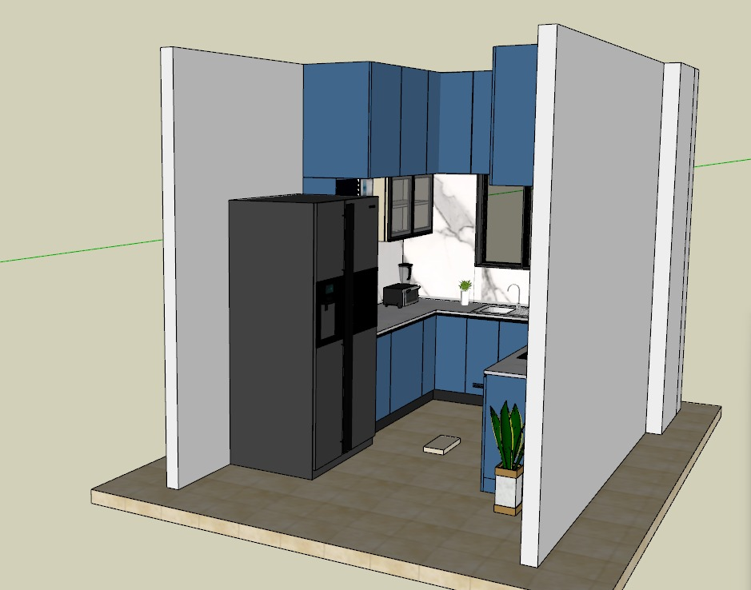
Photo 1
Photo 2

